ACCURATE INSTITUTE OF MANAGEMENT AND TECHNOLOGY  | GREATER NOIDA 201306

**OBJECT ORIENTED PROGRAMMING LAB [ KCA 251 ]**

**SHUBHAM PATKAR**

**MCA 1ST YEAR**

2021

Accurate institute of management & technology

Session 2020-21

Practical file

OBJECT ORIENTED PROGRAMMING LAB [kca-251]

Under guidance of:- Submittedby:-

Prof. ANAND SINGH Shubham patkar

Mca dept. Mca 1st

**INDEX**

|  |  |  |  |
| --- | --- | --- | --- |
| **SR. NO.** | **PROGRAM** | **PAGE NO.** | **TEACHER REMARKS** |
| **1.** | **Write a program to find out the factorial of given number(by takimg user input).** | **5** |  |
| **2** | **Write a program to find out that given number is palindrome or not.** | **6-7** |  |
| **3** | **Write a program that will display the sum of 1+1/2+1/3....+1/n.** | **8** |  |
| **4** | **Write a program that will display 25 prime numbers.** | **9-10** |  |
| **5** | **Write a program that uses the use of inheritance.** | **11** |  |
| **6** | **Write a program to implement Multiple Interfaces.** | **12-13** |  |
| **7** | **Write a program to method overriding.** | **14-15** |  |
| **8** | **Write a program to show the use of abstract class.** | **16-17** |  |
| **9** | **Write a program which shows creation of package and importing of a classes from other packages .** | **18-19** |  |
| **10** | **Write a program to Addition of two matrices .** | **19-20** |  |
| **11** | **Write a program to Multiplication of two matrices .** | **21-22** |  |
| **12** | **Write a program to concept of default constructor in java .** | **23** |  |
| **13** | **Write a program to show sleep concept in java** | **24** |  |
| **14** | **Write a program to handle exception in java** | **25-26** |  |
| **15** | **Write a program to create Frame using java awt.** | **27-28** |  |
| **16** | **Develop GUI applications using Swing components** | **29-32** |  |

**Program-1**

**Write a program to find out the factorial of given number(by takimg user input).**

**class Factorial**

**{**

**public static void main(String args[])**

**{**

**System.out.println("Find Factorial of : 5 ");**

**int i,fact=1;**

**int number=5;**

**for(i=1;i<=number;i++)**

**{**

**fact=fact*i;**

**}**

**System.out.println("Factorial of "+number+" is: "+fact);**

**}**

**}**

**Output –**

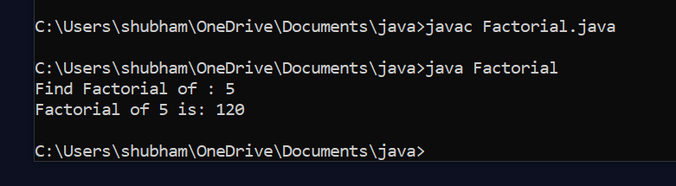

**Program-2**

**Write a program to find out that given number is palindrome or not.**

**import java.util.*;**

**class Palindrome**

**{**

**public static void main(String args[])**

**{**

**String original, reverse = ""; // Objects of String class**

**Scanner in = new Scanner(System.in);**

**System.out.println("Enter a string/number to check if it is a palindrome");**

**original = in.nextLine();**

**int length = original.length();**

**for ( int i = length - 1; i >= 0; i-- )**

**reverse = reverse + original.charAt(i);**

**if (original.equals(reverse))**

**System.out.println("Entered string/number is a palindrome.");**

**else**

**System.out.println("Entered string/number isn't a palindrome.");**

**}**

**}**

**Output -**

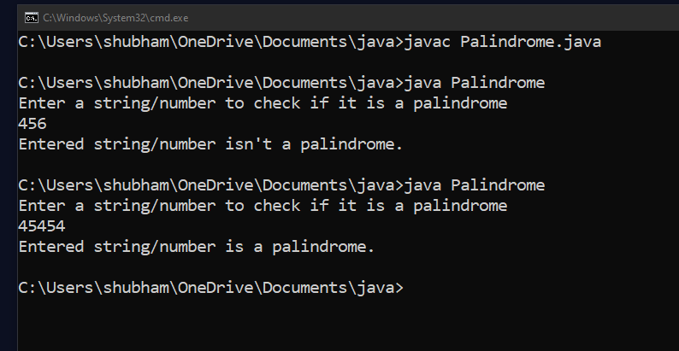

**Program-3**

**Write a program that will display the sum of 1+1/2+1/3....+1/n.**

**import java.util.Scanner;**

**public class series**

**{**

**public static void main(String[] args)**

**{**

**Scanner sc=new Scanner(System.in);**

**System.out.print("Enter n: ");**

**int n = sc.nextInt;**

**double sum=0;**

**for(int i=1;i<=n:i++)**

**{**

**long f=1;**

**for(int j=1;i<=n:j++)**

**{**

**f *=j;**

**}**

**Sum+=(1.0/f);**

**}**

**System.out.println("Sum= + sum);**

**} }**

**Output -**

**Enter n: 10**

**Sum=1.7182818011463847**

**Program-4**

**Write a program that will display 25 prime numbers.**

**public class PrimeNum**

**{**

**public static void main(String args[])**

**{**

**int i,m=0,flag=0;**

**int n=3;**

**m=n/2;**

**if(n==0||n==1)**

**{**

**System.out.println(n+" is not prime number");**

**}**

**else**

**{**

**for(i=2;i<=m;i++){**

**if(n%i==0){**

**System.out.println(n+" is not prime number");**

**flag=1;**

**break;**

**}**

**}**

**if(flag==0)**

**{**

**System.out.println(n+" is prime number");**

**}**

**}**

**}**

**}**

**Output -**

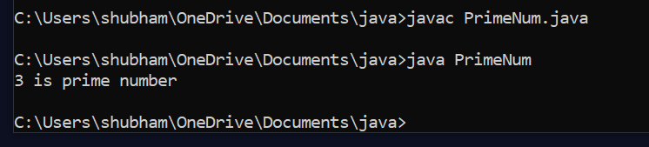

**Program-5**

**Write a program that uses the use of inheritance.**

**class First**

**{**

**int i=10;**

**void inherit()**

**{**

**System.out.println("Hello");**

**}**

**}**

**class Second extends First**

**{**

**void inherit()**

**{**

**System.out.println("World");**

**}**

**public static void main(String args[])**

**{**

**Second s=new Second();**

**s.inherit();**

**System.out.println(s.i);**

**}}**

**Output -**

**Hello World**

**Program-6**

**Write a program to implement Multiple Interfaces.**

**interface A**

**{**

**void show();**

**}**

**interface B**

**{**

**void disp();**

**}**

**class INNER implements A,B**

**{**

**public void show()**

**{**

**System.out.println("This Is Interface A");**

**}**

**public void disp()**

**{**

**System.out.println("This Is Interface B");**

**}**

**public static void main(String arg[])**

**{**

**INNER obj= new INNER();**

**obj.show();**

**obj.disp();**

**}**

**}**

**Output -**

**This is Interface A**

**This is Interface B**

**Program-7**

**Write a program to method overriding.**

**class Vehicle**

**{**

**void run()**

**{**

**System.out.println("Vehicle is running");**

**}**

**}**

**class Bike2 extends Vehicle**

**{**

**void run()**

**{**

**System.out.println("Bike is Running Fast");**

**}**

**public static void main(String args[])**

**{**

**Bike2 obj = new Bike2();**

**obj.run();**

**}**

**}**

**Output -**

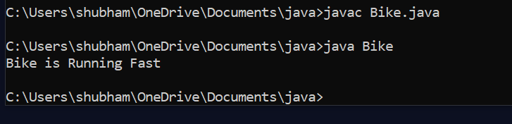

**Program-8**

**Write a program to show the use of abstract class.**

**abstract class Sum**

**{**

**public abstract int sumOfTwo(int n1, int n2);**

**public abstract int sumOfThree(int n1, int n2, int n3);**

**public void display()**

**{**

**System.out.println("Method of class Sum :");**

**}**

**}**

**class Demo extends Sum**

**{**

**public int sumOfTwo(int num1, int num2)**

**{**

**return num1+num2;**

**}**

**public int sumOfThree(int num1, int num2, int num3)**

**{**

**return num1+num2+num3;**

**}**

**public static void main(String args[])**

**{**

**Sum obj = new Demo();**

**System.out.println(obj.sumOfTwo(3, 7));**

**System.out.println(obj.sumOfThree(4, 3, 19));**

**obj.display();**

**}**

**}**

**Output -**

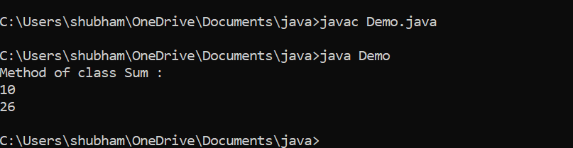

**Program-9**

**Write a program which shows creation of package and importing of a classes from other packages .**

**package pack1;**

**import pack2.Student**

**public class Example**

**{**

**public static void main(String []args)**

**{**

**Student s1=new Student();**

**s1.setRollno(22);**

**s1.setName("Shubham !");**

**}**

**System.out.println("Student Roll Number = "+getRollno());**

**System.out.println("Student Full Name = "+getName());**

**}**

**Output –**

**Student Roll Number = 22**

**Student Full Name = Shubham !**

**Program-10**

**Write a program to Addition of two matrices .**

**class ArrAddMatrics{**

**public static void main(String args[]){**

**int m1[][]={{2,4,6},{3,5,7},{4,8,12}};**

**int m2[][]={{2,4,6},{3,5,7},{4,8,12}};**

**int add[][]=new int[3][3];**

**System.out.println("Addition of matrix");**

**for(int i=0;i<3;i++)**

**{**

**for(int j=0;j<3;j++)**

**{**

**add[i][j]=0;**

**for(int k=0;k<3;k++)**

**{**

**add[i][j]=add[i][j]+m1[i][k]+m2[k][j];**

**System.out.print(add[i][j]+" ");**

**}**

**System.out.println();**

**}**

**} }**

**}**

**OUTPUT**

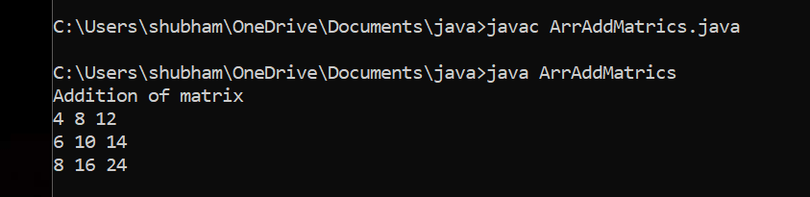

**Program-11**

**Write a program to Multiplication of two matrices .**

**class ArrMulMatrics{**

**public static void main(String args[]){**

**int m1[][]={{2,4,6},{3,5,7},{4,8,12}};**

**int m2[][]={{2,4,6},{3,5,7},{4,8,12}};**

**int mul[][]=new int[3][3];**

**System.out.println("Multiplication of matrix");**

**for(int i=0;i<3;i++)**

**{**

**for(int j=0;j<3;j++)**

**{**

**mul[i][j]=0;**

**for(int k=0;k<3;k++)**

**{**

**mul[i][j]=mul[i][j]+m1[i][k]+m2[k][j];**

**}**

**System.out.print(mul[i][j]+" ");**

**}**

**System.out.println();**

**}**

**}**

**}**

**OUTPUT**

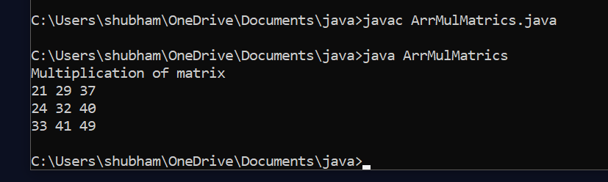

**Program-12**

**Write a program to concept of default constructor in java .**

**class DefaultConstructor{**

**int rollno;**

**String name;**

**void display(int r,String n){**

**rollno=r;**

**name=n;**

**System.out.println("Student Roll number : "+rollno+" Student Name : "+name);**

**}**

**public static void main(String args[]){**

**DefaultConstructor st=new DefaultConstructor();**

**st.display(10,"SHUBHAM PATKAR");**

**}**

**}**

**OUTPUT**

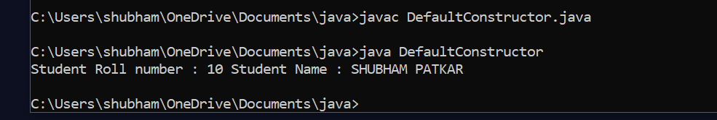

**Program-13**

**Write a program to show sleep concept in java**

**class Sleep{**

**public static void main(String args[]) throws InterruptedException{**

**Thread.sleep(5000);**

**System.out.println("Hello, Shubham Patkar !");**

**Thread.sleep(4000);**

**System.out.println("-: Web Developer :-");**

**}**

**}**

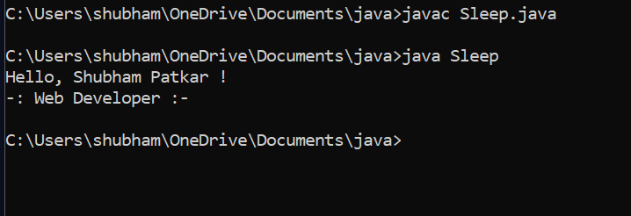

**Program-14**

**Write a program to handle exception in java**

**import java.util.Scanner;**

**class ExceptionHand{**

**public static void main(String args[]){**

**System.out.print("enter first :");**

**Scanner sc=new Scanner(System.in);**

**int a=sc.nextInt();**

**System.out.print("enter second :");**

**int b=sc.nextInt();**

**System.out.print("enter third :");**

**int c=sc.nextInt();**

**try**

**{**

**int d=(a+b)/c;**

**System.out.println("the value of D :"+d);**

**}**

**catch(ArithmeticException e){**

**System.out.println("zero excep handle");**

**}**

**int e=(a+b)/a;**

**System.out.println("the value of E :"+e);**

**}**

**}**

**OUTPUT**

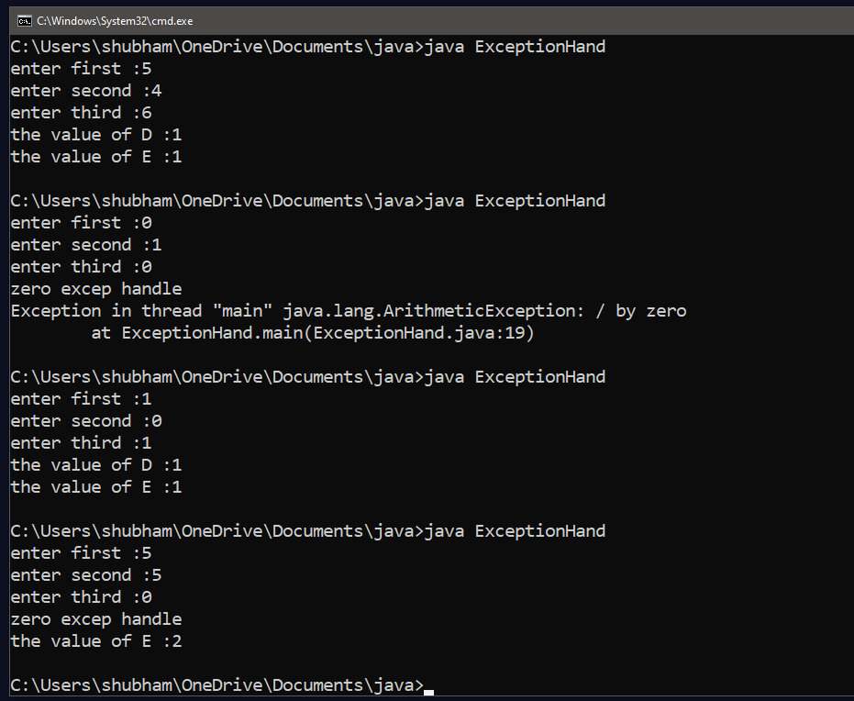

**Program-15**

**Write a program to create Frame using java awt.**

**import java.awt.*;**

**class FirstFrameEx extends Frame{**

**FirstFrameEx(){**

**this.setVisible(true);**

**this.setSize(1000,300);**

**this.setBackground(Color.green);**

**this.setTitle("FirstFrame EX");**

**}**

**public void paint(Graphics g){**

**Font font =new Font("arial",Font.ITALIC+Font.BOLD,35);**

**g.setFont(font);**

**g.drawString("Shubham",200,100);**

**this.setForeground(Color.red);**

**}**

**}**

**class FrameExtends{**

**public static void main(String args[]){**

**FirstFrameEx ff=new FirstFrameEx();**

**}**

**}**

**OUTPUT**

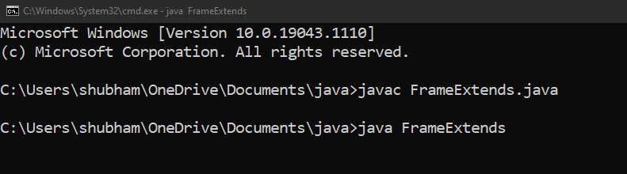

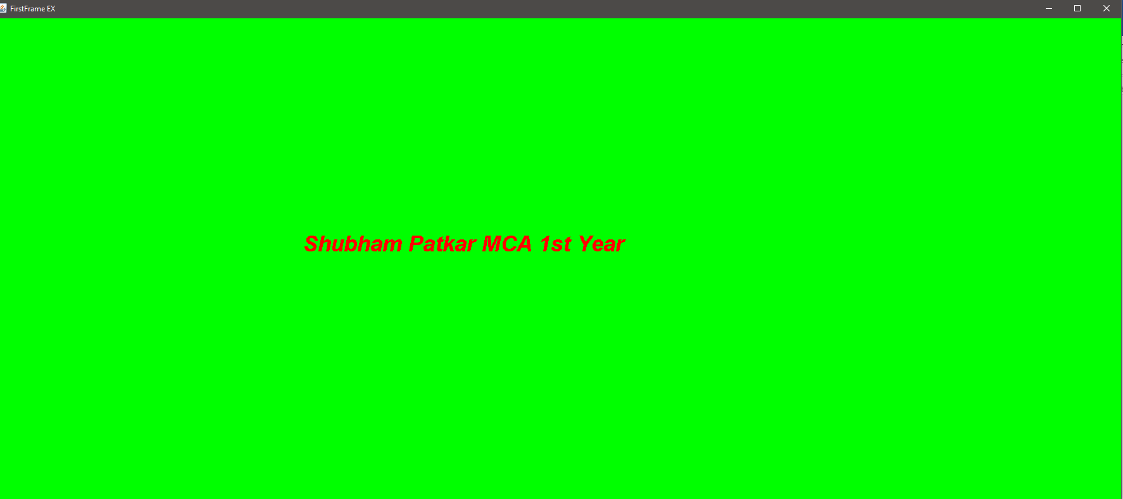

**Program-16**

**Develop GUI applications using Swing components**

**import javax.swing.*;**

**import java.awt.*;**

**import java.awt.event.*;**

**class ChessBoard extends JFrame**

**{**

**JButton [][]bt=new JButton[8][8];**

**public ChessBoard()**

**{**

**super("Chess");**

**setExtendedState(6);**

**setDefaultCloseOperation(3);**

**addButtons();**

**setVisible(true);**

**}**

**private void addButtons()**

**{**

**setLayout(new GridLayout(8,8));**

**int c=0;**

**ChessListener listener=new ChessListener();**

**for(int i=0;i<8;i++)**

**{**

**for(int j=0;j<8;j++)**

**{**

**bt[i][j]=new JButton();**

**bt[i][j].addActionListener(listener);**

**if(j%2==c)**

**bt[i][j].setBackground(Color.white);**

**else**

**bt[i][j].setBackground(Color.black);**

**add(bt[i][j]);**

**}**

**c=1-c;**

**}**

**setImage();**

**}**

**private void setImage()**

**{**

**ImageIcon icon3=new ImageIcon(getClass().getResource("image/bp.gif"));**

**ImageIcon icon4=new ImageIcon(getClass().getResource("image/wp.gif"));**

**for(int c=0;c<8;c++)**

**{**

**ImageIcon icon1=new ImageIcon(getClass().getResource("image/b"+c+".gif"));**

**bt[0][c].setIcon(icon1);**

**ImageIcon icon2=new ImageIcon(getClass().getResource("image/w"+c+".gif"));**

**bt[7][c].setIcon(icon2);**

**bt[1][c].setIcon(icon3);**

**bt[6][c].setIcon(icon4);**

**}**

**}**

**class ChessListener implements ActionListener**

**{**

**public void actionPerformed(ActionEvent evt)**

**{**

**JButton bc=(JButton)evt.getSource();**

**Icon ic=bc.getIcon();**

**bt[5][0].setIcon(ic);**

**bc.setIcon(null);**

**}**

**}**

**public static void main(String []args)**

**{**

**setDefaultLookAndFeelDecorated(true);**

**new ChessBoard();**

**}**

**}**

**OUTPUT**



